**Starting Another Activity**

1. Respond to the Send Button

* In Android Studio, from the res/layout directory, edit the activity_my.xml file.
* To the <Button> element, add the android:onClick attribute.

Result:

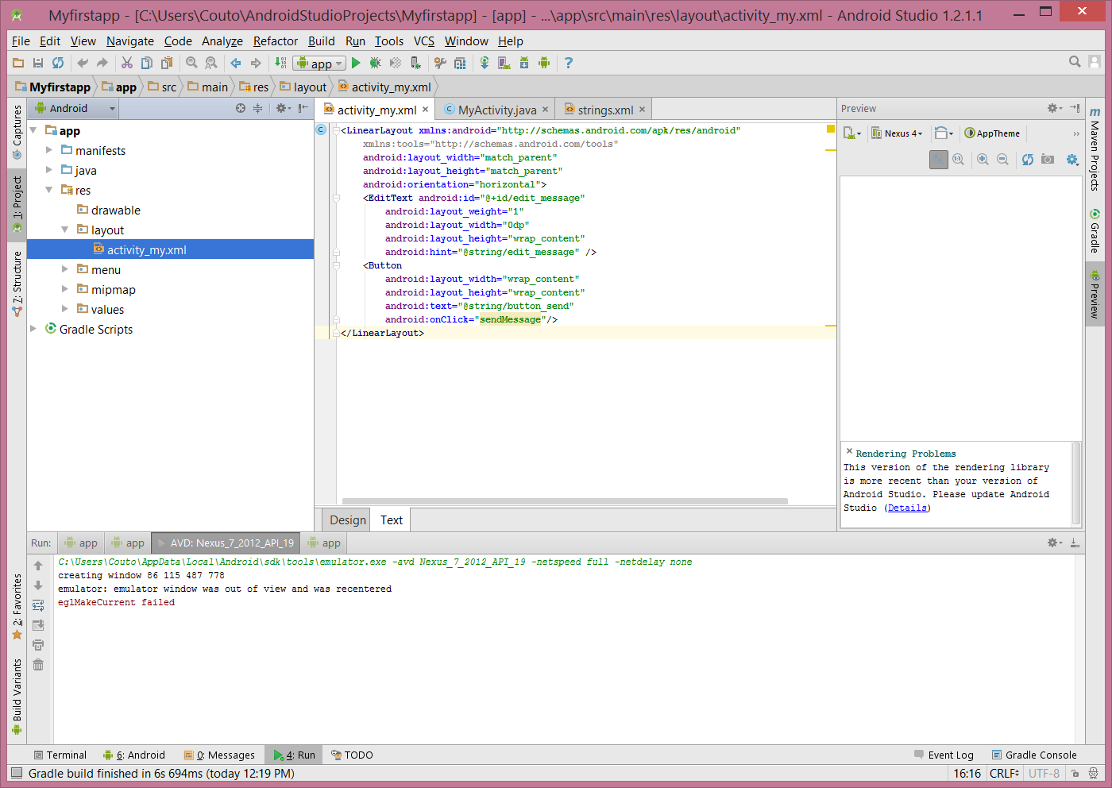

* In the java/com.mycompany.myfirstapp directory, open the MyActivity.java file.
* Within the MyActivity class, add the sendMessage() method stub shown below.

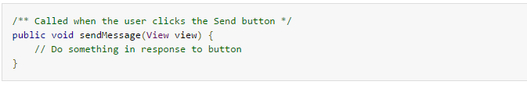

Result

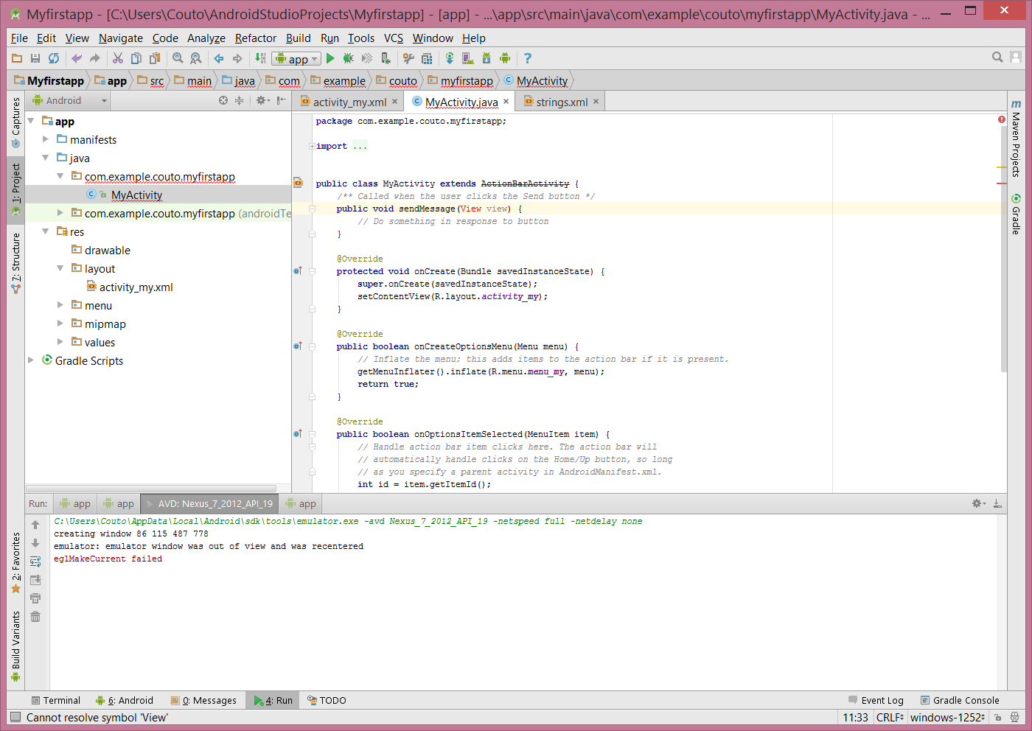

1. Build an Intent

* In MyActivity.java, inside the sendMessage() method, create an Intent to start an activity called DisplayMessageActivity with the following code:

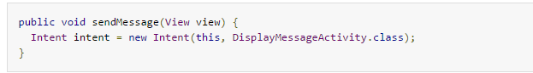

Note: The reference to DisplayMessageActivity will raise an error if you’re using an IDE such as Android Studio because the class doesn’t exist yet. Ignore the error for now; you’ll create the class soon.

* At the top of the file, import Itent class:



* Inside the sendMessage() method, use findViewById() to get the EditText element.

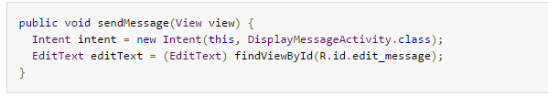

* At the top of the file, import the EditText class.
* In Android Studio, press Alt + Enter (option + return on Mac) to import missing classes.
* Assign the text to a local message variable, and use the putExtra() method to add its text value to the intent.

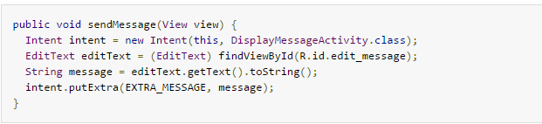

* At the top of the MyActivity class, add the EXTRA_MESSAGE definition as follows:

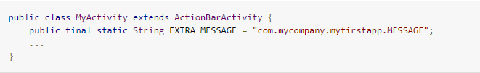

* In the sendMessage() method, to finish the intent, call the startActivity() method, passing it the Intent object created in step 1

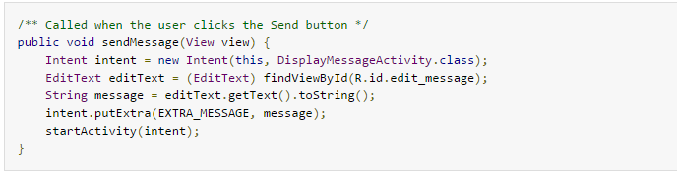

Result:

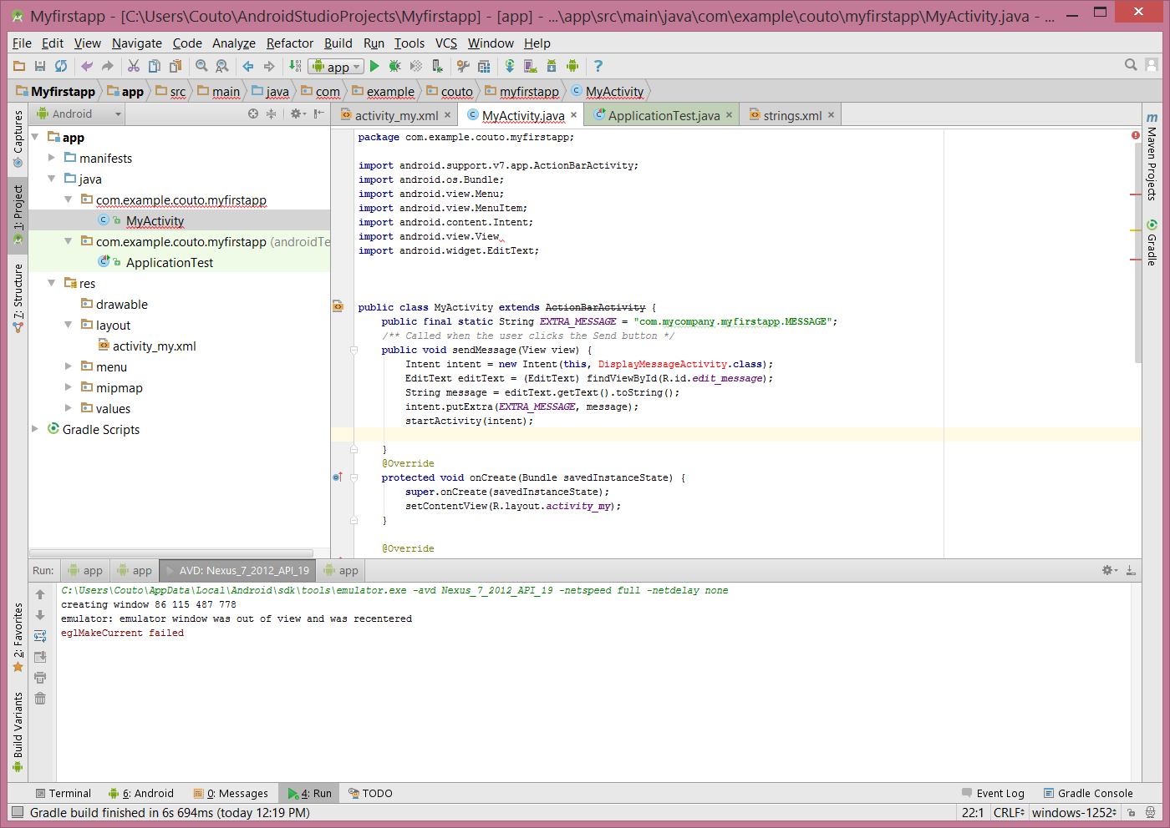

1. Create a new activity using Android Studio

* In Android Studio, in the java directory, select the package, com.mycompany.myfirstapp, right-click, and select New > Activity > Blank Activity.

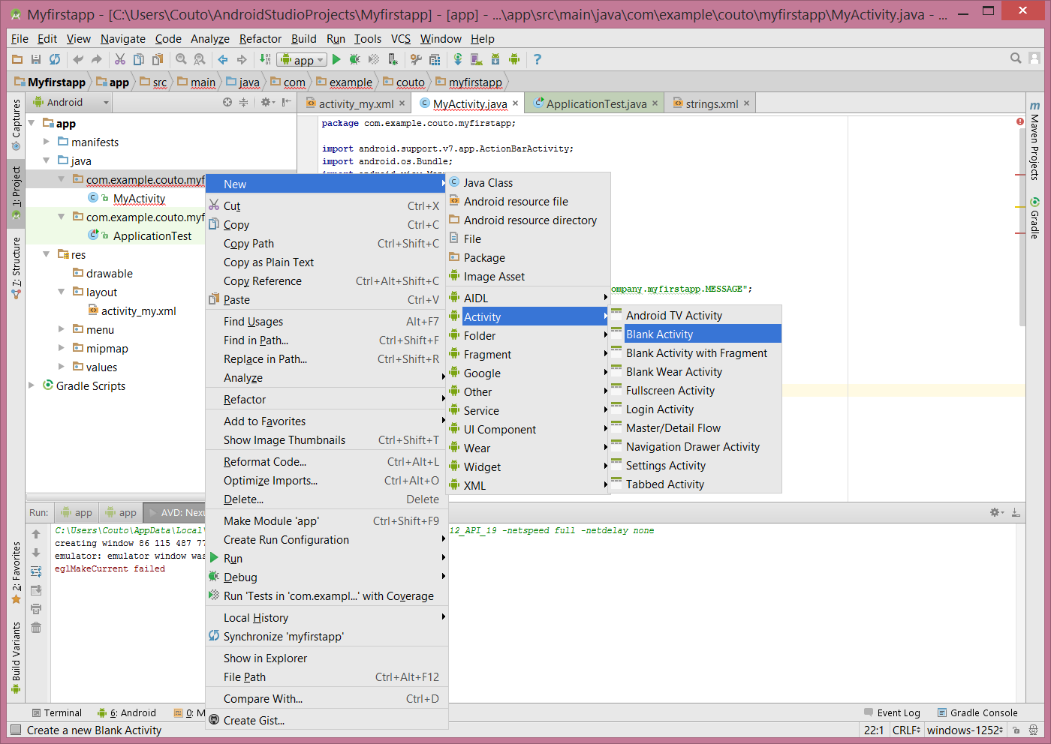

* In the Choose options window, fill in the activity details:

Activity Name: DisplayMessageActivity

Layout Name: activity_display_message

Title: My Message

Hierarchical Parent: com.mycompany.myfirstapp.MyActivity

Package name: com.mycompany.myfirstapp

* Click Finish.
* Open the DisplayMessageActivity.java file.
* Remove the onCreateOptionsMenu() method.

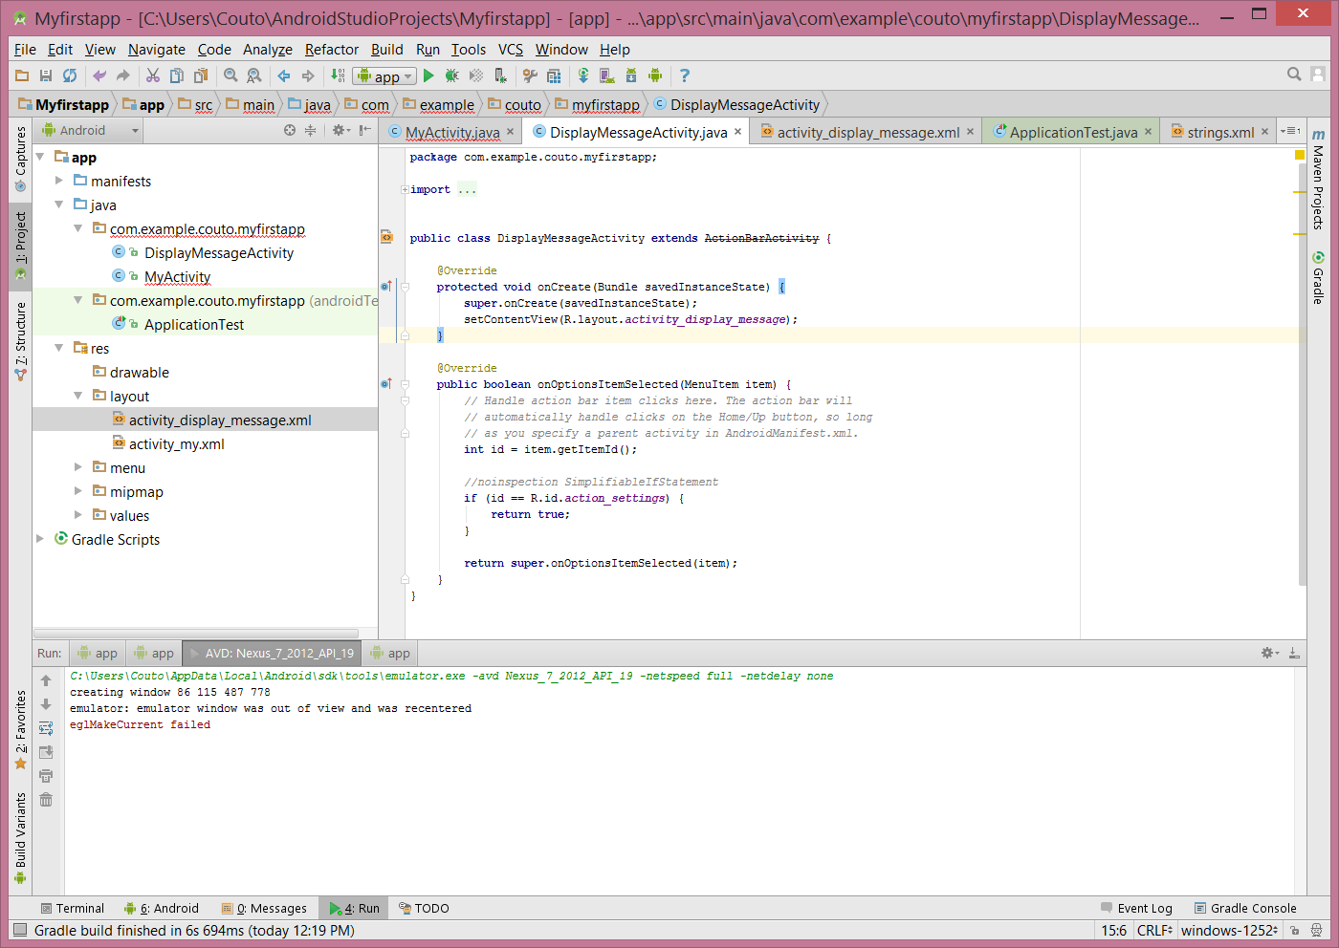

1. Receive the Intent

* In the java/com.mycompany.myfirstapp directory, edit the DisplayMessageActivity.java file.
* In the onCreate() method, remove the following line:



* Get the intent and assign it to a local variable.



In Android Studio, press Alt + Enter (option + return on Mac) to import missing classes.

* Extract the message delivered by MyActivity with the getStringExtra() method.



Result:

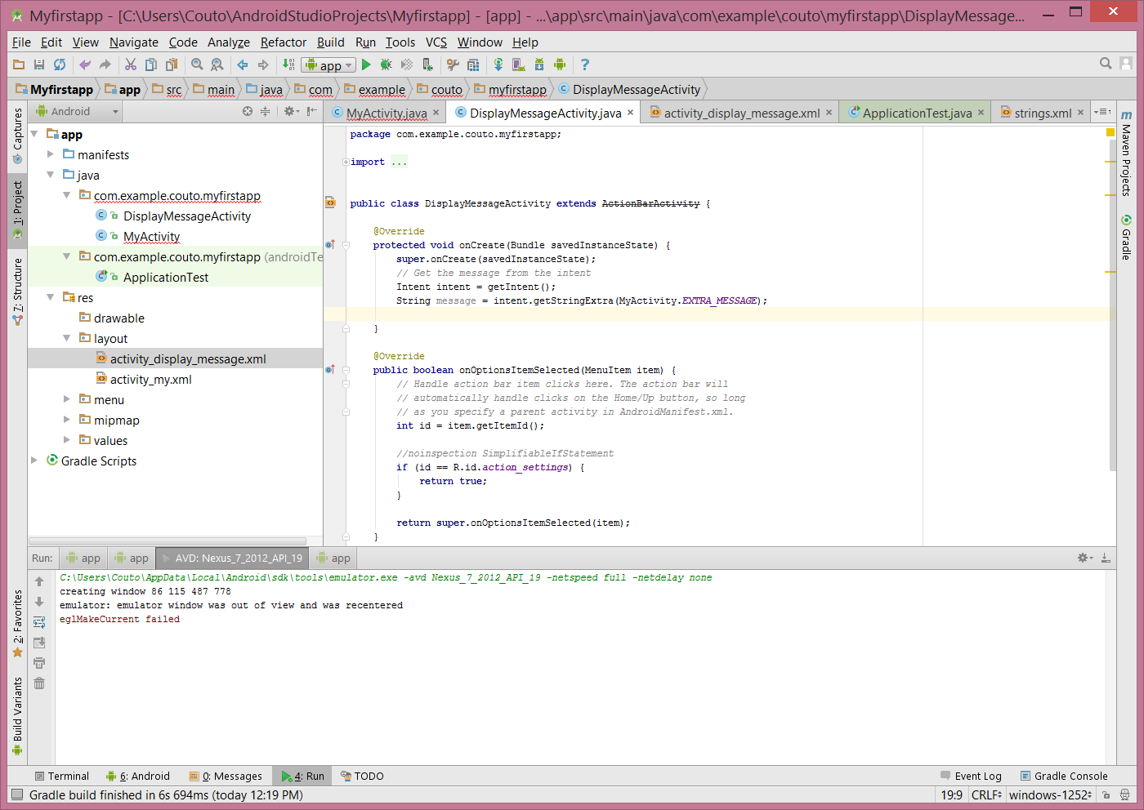

1. Display the Message

* In the onCreate() method, create a TextView object.



* Set the text size and message with setText().

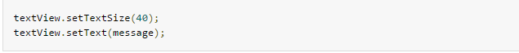

* Then add the TextView as the root view of the activity’s layout by passing it to setContentView().



At the top of the file, import the TextView class. In Android Studio, press Alt + Enter (option + return on Mac) to import missing classes.

Result:

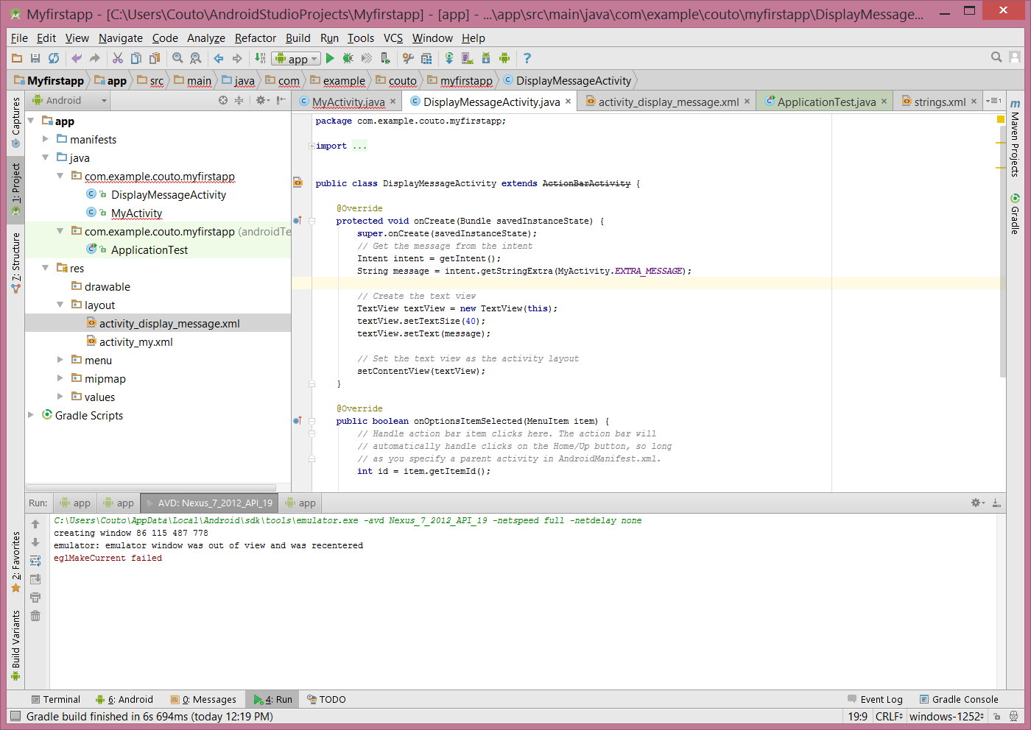

1. Run your app!

